Introduction to the Nanoworld

“Teeny Tiny Science”

Linda Shore
lindas@exploratorium.edu

Got Nano?
Is nanotechnology involved in your everyday life or is nanoscience confined to the laboratory? Here is a way to introduce students to the relevance of nanosciences to their everyday lives.

This activity was developed with funding from the National Science Foundation (Grant No.ESI-0532536).

Materials Needed
• 30 Index cards (one for each student)
• Labels (see attached)
• Scissors
• Scotch tape or glue sticks

What To Do:
- Make enough copies of the attached labels so that each student in your class will have one label.


- Cut out the labels and prepare index cards at advance. Each index card should have the name of a location in the body glued on it (Figure 1). Make one card for every student in your class.

HIV Virus

Figure 1

- To prepare the class for this activity, ask students what they already know about nanoscience and nanotechnology. Do they think that nanoscience and nanotechnology has any relevance to their lives? If so, how?

- Tell students that each card contains an example of some common nanoscale objects that are encountered in everyday life. Tape one card on the back of each student. Make sure the student has not seen the card and instruct students not to tell others what is on their backs. They will be playing a game where each student will have to guess what part of the body is on their backs.

- Students are to wander around the room asking each other "yes or no" questions. For example, for the card above, a student may ask "is this nanoscale object something I eat?” Or “is this nanoparticle in computers? “Is this nanoparticle in my body?” Students should not give more than "yes" or "no" as a response to a question. Also, students are limited to asking each other three questions -- then they need to find another classmate.

- To indicate they have successfully guessed their nanoscale object, students should remove the index card from their backs and attach them to their chest. However, these students should still help others guess their cycle by answering "yes-no" questions.

- Once every one has correctly guessed their nanoscale object, student with the same nano object should gather in a group (for example, all students with “HIV Virus” are a group; all students with “Interstellar Dust” are another group).

- Students in each group should use the websites listed below to help answer the following questions:

  - About how large is this object (in nanometers)?

  - Why is this object important in science research or in engineering?

Groups should present the results of their web research to the rest of the class.

EXTENSION. If we use a scale in which a ping-pong ball has a diameter of 1 nanometer, create a scale model of the object using materials provided (e.g. chenille stems, drinking straws, modeling clay, beads, marbles, string, etc.

Websites

Pollen
http://www.nanowerk.com/news/newsid=4142.php

http://rcuknano.org.uk/impact/pollen-nanotags-to-combat-gun-crime.html

http://www.nanotech-now.com/news.cgi?story_id=36897

Gold Nanoparticles

http://health.howstuffworks.com/medicine/modern/gold-nanotech.htm

http://www.sciencedaily.com/releases/2010/06/100615122534.htm

http://news.discovery.com/tech/gold-nanoparticles-disease-detection.html

HIV Virus
http://nanogloss.com/nanotechnology/nanotechnology-that-might-cure-hiv/

http://www.mos.org/educators/student_resources/videocasts&d=3319

http://www.nanotechnologyworld.co.uk/content/view/604/2/

DNA
http://www.sciencedaily.com/releases/2008/01/080130130655.htm

http://en.wikipedia.org/wiki/DNA_nanotechnology

http://sciencestage.com/flvplayer.swf?autostart=true&backcolor=0xFFFFFF&displayheight=414&displaywidth=590&file=http://sciencestage.com/uploads/vojzvcz2jzxkyp7i.flv&height=414&link=http://sciencestage.com/v/244/paul-rothemund-creativity-dna-macarthur-grant-nanoscale-physics-science.html&linktarget=_blank&showfsbutton=false&width=550

Water Molecules
http://www.eurekalert.org/pub_releases/2007-04/giot-wfl042407.php

http://arstechnica.com/science/news/2009/04/understanding-how-water-and-nanotubes-generate-energy.ars

http://www.singularity2050.com/2006/06/nanotechnology_.html

Magnetic Nanoparticles
http://www.wired.com/wiredscience/2010/07/magnetic-nanoparticles-can-remotely-control-worms/

http://www.physorg.com/news198570612.html

http://www.mrsec.wisc.edu/Edetc/background/ferrofluid/index.html

Extreme Ultraviolet Light
http://www.wired.com/wiredscience/2009/05/extremelaser/

http://www.erc-assoc.org/factsheets/04/04-EUV%20Fact%20Sheet%20final.htm

http://cnse.albany.edu/downloads/Inside%20CNSE%20Brainard.wmv

Interstellar Dust
http://en.wikipedia.org/wiki/Cosmic_dust

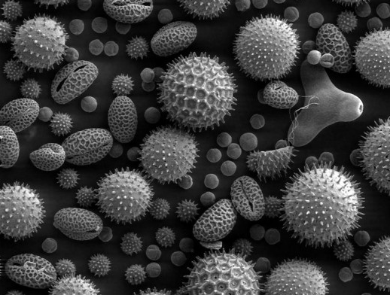

Pollen

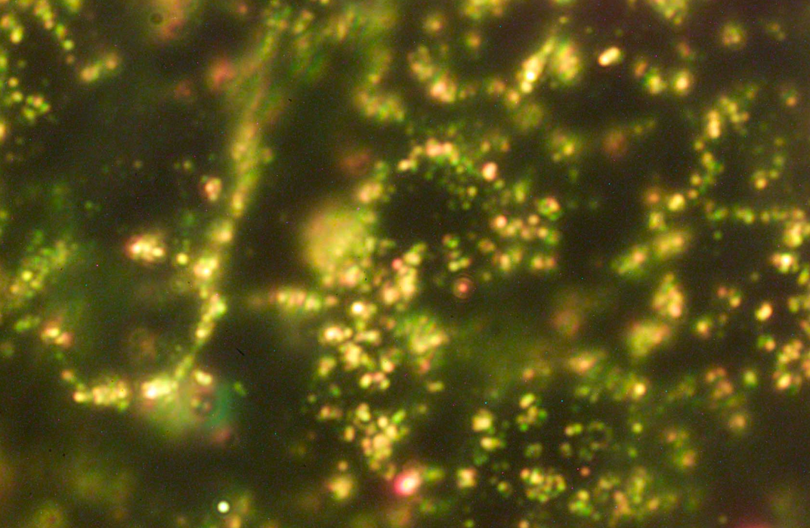

Gold Nanoparticles

HIV Virus

DNA

Water Molecule

Magnetic Nanoparticles

A ferrofluid

Short Wavelength (Extreme)

Ultraviolet Light

Interstellar Dust
Nanoparticles

